**Support Vector Machines (SVM)**

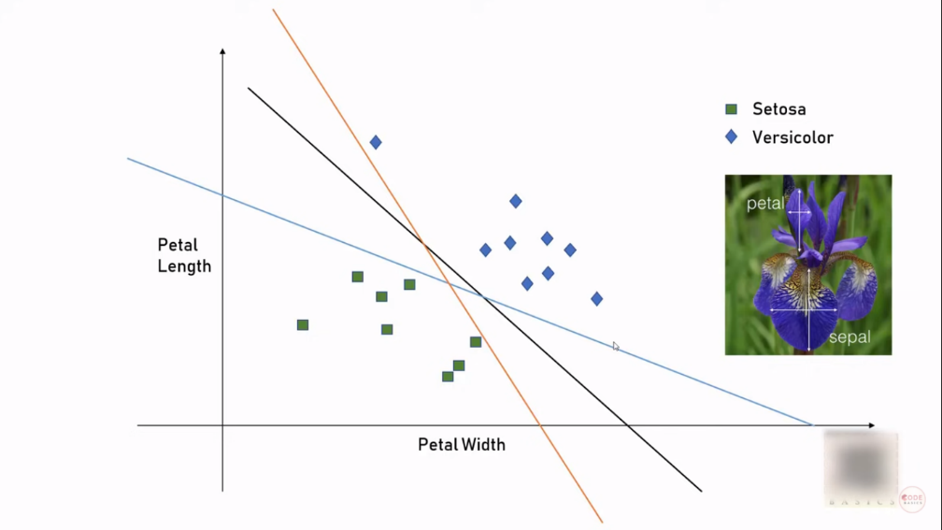(Classification and Regression problems)

For classification, there can be multiple possibilities for drawing the decision boundary. (refer fig)

So how do we decide which boundary is best for my classification problem?

**Approach 1:**  Maximize the margin (i.e. Distance between the nearby points and decision boundary). The datapoints are called support vectors. For 2d, decision bdry is line. For 3d, decision bdry is plane. For nd, decision bdry is hyperplane

**Support Vector Machines** draws a hyperplane in n dimensional space such that it maximizes margin between classification groups

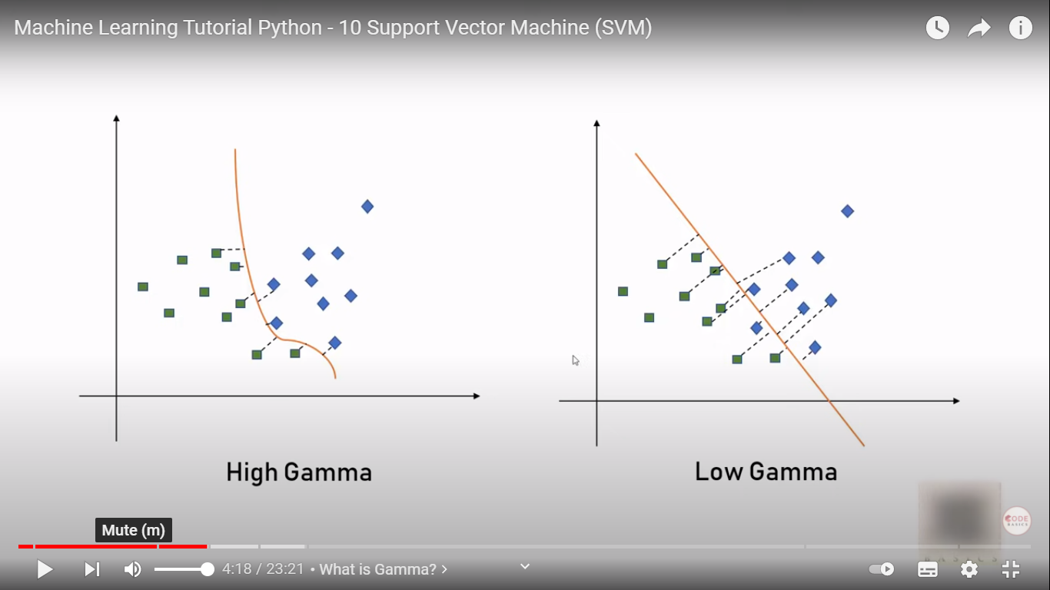**TERMS:**

**Gamma:**

Suppose, we consider only the nearby datapts for drawing the decision bdry (excluding far datapts). This is an example of ‘High Gamma’

Suppose, we consider nearby and far away datapts for drawing the decision bdry. This is an example of ‘Low Gamma’

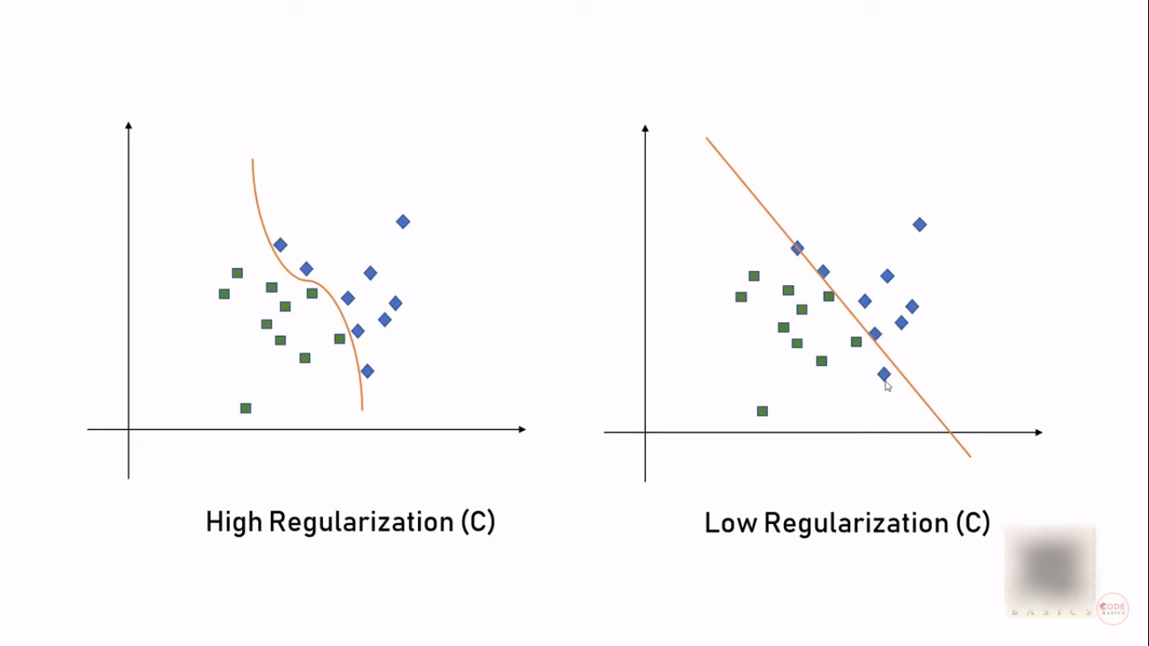**Regularization**

Suppose, we draw the decision bdry very carefully (almost overfitting) … might be a case with complex datasets. The line would be a complex curve. But the scope of misclassification is reduced. This is an example of ‘High regularization’

Suppose, We draw the decision bdry with some relaxations. Here the line would be much smoother. But also possibility of misclassification of odd datapt. This is an example of ‘low regularization’